primerejerciciocompilar.R

apalmad

2021-01-09

#cargar Librerias  
library(readxl)  
  
#setear directorios  
setwd("C:/Users/apalmad/Desktop/Analiza tus Datos/Bloque 2/Empieza con tu Software")  
  
  
  
# Leer Datos  
  
datos <- read_excel("espalda-para-R.xlsx")  
  
  
# Manipular tabla de datos  
diff_oddi <- datos[,9] - datos[,10]  
names(diff_oddi) <- "DiffOdi"  
datos <- cbind(datos,diff_oddi)  
  
  
  
  
# DESCRIPCION  
summary(datos)

## Id Paciente Sexo Edad Peso   
## Min. : 1.00 Min. :0.000 Min. :29.00 Min. : 44.66   
## 1st Qu.: 50.75 1st Qu.:0.000 1st Qu.:50.00 1st Qu.: 67.45   
## Median :100.50 Median :0.000 Median :60.50 Median : 72.67   
## Mean :100.50 Mean :0.495 Mean :59.14 Mean : 74.67   
## 3rd Qu.:150.25 3rd Qu.:1.000 3rd Qu.:67.00 3rd Qu.: 76.83   
## Max. :200.00 Max. :1.000 Max. :88.00 Max. :109.20   
## Altura LC PC NHD   
## Min. :1.310 Min. :0.000 Min. :0.000 Min. :0.000   
## 1st Qu.:1.647 1st Qu.:0.000 1st Qu.:0.000 1st Qu.:0.000   
## Median :1.770 Median :1.000 Median :1.000 Median :1.000   
## Mean :1.769 Mean :0.865 Mean :1.045 Mean :0.725   
## 3rd Qu.:1.883 3rd Qu.:2.000 3rd Qu.:2.000 3rd Qu.:1.000   
## Max. :2.390 Max. :2.000 Max. :2.000 Max. :2.000   
## ODI Mes0 ODI Mes1 Grupo DiffOdi   
## Min. :25.20 Min. : 3.60 Length:200 Min. : 5.00   
## 1st Qu.:54.67 1st Qu.:27.30 Class :character 1st Qu.: 9.95   
## Median :65.40 Median :36.15 Mode :character Median :24.15   
## Mean :64.16 Mean :39.63 Mean :24.53   
## 3rd Qu.:74.17 3rd Qu.:54.42 3rd Qu.:43.30   
## Max. :93.90 Max. :82.90 Max. :45.00

colMeans(datos[,c(3,4,5,12)])

## Edad Peso Altura DiffOdi   
## 59.14000 74.66805 1.76865 24.52950

# GRAFICOS   
hist(datos[,9],main="Histograma del Mes 0")

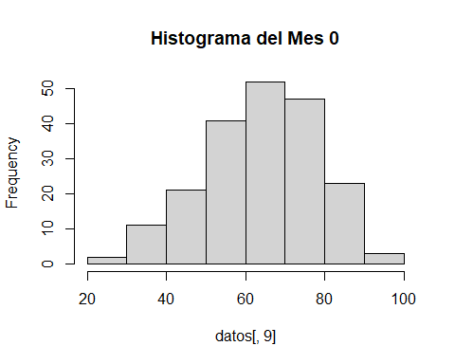

# ANALISIS